**MINI PROJECT**

**(2020-21)**

**“E-Commerce Website”**

Project Report



**Institute of Engineering & Technology**

**Submitted By –**

Prateek Gupta (191500587)

Anuj Kumar Yadav (191500137)

Under the Supervision Of

**Mr. Mandeep Singh**

**Technical Trainer**

**Department of Computer Engineering & Application**

**Declaration**

I/we hereby declare that the work which is being presented in the Bachelor of technology. Project **“E-Commerce website”**, in partial fulfilment of the requirements for the award of the ***Bachelor of Technology*** in Computer Science and Engineering and submitted to the Department of Computer Engineering and Applications of GLA University, Mathura, is an authentic record of my/our own work carried under the supervision of **Mr. Mandeep Singh, Technical Trainer, Dept. of CEA, GLA University.**

The contents of this project report, in full or in parts, have not been submitted to any other Institute or University for the award of any degree.

|  |  |
| --- | --- |
|  |  |
| **Name of Candidate**: Prateek Gupta |  |
| **University Roll No**.:191500587 |  |
| |  | | --- | | **Name of Candidate**: Anuj Kumar Yadav | | **University Roll No**.:191500137 | |  |

# Certificate

This is to certify that the project entitled “E-Commerce Website”, carried out in Mini Project – I Lab, is a Bonafede work by Prateek Gupta and Anuj Kumar Yadav and is submitted in partial fulfilment of the requirements for the award of the degree Bachelor of Technology (Computer Science & Engineering).

**Signature of Supervisor:**

**Name of Supervisor:** Mr. Mandeep Singh

## 

## ACKNOWLEDGEMENT

Presenting the ascribed project paper report in this very simple and official form, we would like to place my deep gratitude to GLA University for providing us the instructor Mr Mandeep Singh, our technical trainer and supervisor.

He has been helping us since Day 1 in this project. He provided us with the roadmap, the basic guidelines explaining on how to work on the project. He has been conducting regular meeting to check the progress of the project and providing us with the resources related to the project. Without his help, we wouldn’t have been able to complete this project.

And at last, but not the least we would like to thank our dear parents for helping us to grab this opportunity to get trained and also my colleagues who helped me find resources during the training.

### Thanking You

|  |
| --- |
| **Name of Candidate**: Prateek Gupta |
| **University Roll No**.:191500587 |
| |  | | --- | | **Name of Candidate**: Anuj Kumar Yadav | | **University Roll No**.:191500137 | |

**ABSTRACT**

Electronic Commerce is process of doing business through computer networks. A person sitting on his chair in front of a computer can access all the facilities of the Internet to buy or sell the products.

Unlike traditional commerce that is carried out physically with effort of a person to go & get products, ecommerce has made it easier for human to reduce physical work and to save time.    E-Commerce which was started in early 1990’s has taken a great leap in the world of computers, but the fact that has hindered the growth of e-commerce is security. Security is the challenge facing e-commerce today & there is still a lot of advancement made in the field of security.

The main advantage of e-commerce over traditional commerce is the user can browse online shops, compare prices and order merchandise sitting at home on their PC.

For increasing the use of e-commerce in developing countries the B2B e-commerce is implemented for improving access to global markets for firms in developing countries. For a developing country advancement in the field of e-commerce is essential. The research strategy shows the importance of the e-commerce in developing countries for business applications.

**CONTENTS**

Cover Page .......................................................................................................i

Declaration ......................................................................................................ii Certificate..........................................................................................................iii

Acknowledgement ............................................................................................iv

Abstract .............................................................................................................v

Content .............................................................................................................vi

Chapter 1: Introduction

Overview ……………………………………………………………………………………………………… 1

Background Study ………………………………………………………………………………………… 2

Project Planning …………………………………………………………………………………………... 2

Purposes ……………………………………………………………………………………………………… 3

Chapter 2: Hardware and Software Requirement

Hardware and Software Required ………………………………………………………………… 4

Chapter 3: Implementing Tools for the Project

Tools ……………………………………………………………………………………………………………. 5

HTML …………………………………………………………………………………………………………… 5

CSS ………………………………………………………………………………………………………………. 6

JAVASCRIPT …………………………………………………………………………………………………. 6

MySQL …………………………………………………………………………………………………………. 7

Chapter 4: Project Database and User Interface

Database………………………………………………………………………………………………………... 8

User Interface…………………………………………………………………………………………………. 9

Chapter 5: Software Testing

Why software testing is needed …………………………………………………………………. 10

Testing Strategy …………………………………………………………………………………………. 10

White box testing ………………………………………………………………………………………. 11

Black box testing …………………………………………………………………………………………. 11

Chapter 6: Conclusion

Conclusion ……………………………………………………………………………………………….... 12

Future aspect ………………………………………………………………………………………………. 12

**Introduction**

**1.1 Overview**

The ‘Online E-commerce Web application’ Services department strives to provide solutions to develop and transfer easy and efficient way in the digital age and to help reduces the human pressure and time. To help support shop collections, the digital initiatives, and external partner institution digital projects, It provide services that include the digitization of analogy objects, metadata management, digital preservation, and discovery and access of digital collections. “Shop Management System” is a web application written for all operating systems, designed to help users maintain and organize shop virtually. This software is easy to use for both beginners and advanced users. It features a familiar and well thought-out, an attractive user interface, combined with strong searching Insertion and reporting capabilities. The report generation facility of shop system helps to get a good idea of which are the various items brought by the members, makes users possible to get the product easily.

The ‘Online E-commerce Web application’ Services department strives to provide solutions to develop and transfer easy and efficient way in the digital age and to help reduces the human pressure and time. To help support shop collections, the digital initiatives, and external partner institution digital projects, It provides services that include the digitization of analogy objects, metadata management, digital preservation, and discovery and access of digital collections. “Shop Management System” is a web application written for all operating systems, designed to help users maintain and organize shop virtually. This software is easy to use for both beginners and advanced users. It features a familiar and well thought-out, an attractive user interface, combined with strong searching Insertion and reporting capabilities. The report generation facility of shop system helps to get a good idea of which are the various items brought by the members, makes users possible to get the product easily.

## 1.2 Background Study

E-commerce is fast gaining ground as an accepted and used business paradigm. More and more business houses are implementing web sites providing functionality for performing commercial transactions over the web. It is reasonable to say that the process of shopping on the web is becoming commonplace.

The objective of this project is to develop a general-purpose e-commerce store where any product (such as books, CDs, computers, mobile phones, electronic items, and home appliances) can be bought from the comfort of home through the Internet. However, for implementation purposes, this paper will deal with an online ecommerce store.

An online store is a virtual store on the Internet where customers can browse the catalog and select products of interest. The selected items may be collected in a shopping cart. At checkout time, the items in the shopping cart will be presented as an order. At that time, more information will be needed to complete the transaction. Usually, the customer will be asked to fill or select a billing address, a shipping address, a shipping option, and payment information such as a credit card number. An email notification is sent to the customer as soon as the order is placed.

## 

Project planning is part of project management, which relates to the use of schedules such as Gantt charts to plan and subsequently report progress within the project environment. Initially, the project scope is defined and the appropriate methods for completing the project are determined. Following this step, the durations for the various tasks necessary to complete the work are listed and grouped into a work breakdown structure. The logical dependencies between tasks are defined using an activity network diagram that enables identification of the critical path. Float or slack time in the schedule can be calculated using project management software. Then the necessary resources can be estimated and costs for each activity can be allocated to each resource, giving the total project cost. At this stage, the project plan may be optimized to achieve the appropriate balance between resource usage and project duration to comply with the project objectives. Once established and agreed, the plan becomes what is known as the baseline. Progress will be measured against the baseline throughout the life of the project.

**1.4 Purposes**

The project is about to handle all the information of the shop regarding members. Also it manages resources which were managed and handled by manpower previously. The main purpose of the project is to integrate distinct sections of the shop into consistent manner so that complex functions can be handled smoothly. The project aims at the following matters

* Automation of product manipulation.
* Buying products.
* To manage information of different types of items.
* Consistently update information of all the item.
* Managing security by providing authorized email & password. Manages database efficiently.

**Hardware and Software Requirement**

**System Requirements**: Windows 7/8/10

**Software Required**:

• Technology Implemented: Front-End and Back-End Technologies

• Language: HTML, CSS, JavaScript, PHP

• Database: MySQL

• IDE: Visual Studio Code

• Browser: Google Chrome

**Hardware Requirements**:

• Processor: Intel i3

• Operating System: Windows 7/8/10

• RAM: 4GB

• Hard disk: 64 GB

• Hardware Devices: Computer System

**Implementing Tools for the Project**

### 4.1 Tools

* HTML
* CSS
* JAVA SCRIPT (JS)
* MySQL

## 4.2 HTML

Every webpage you look at is written in a language called HTML. You can think of HTML as the skeleton that gives every webpage structure. In this course, we'll use HTML to add paragraphs, headings, images and links to a webpage.

In the editor to the right, there's a tab called test.html. This is the file we'll type our HTML into. Like any language, it has its own special syntax. A browser's job is to transform the code in test.html into a recognizable webpage! It knows how to lay out the page by following the HTML syntax.

## 4.3 CSS

Cascading Style Sheets (CSS) is a style sheet language used for describing the presentation of a document written in a markup language.[1] Most often used to set the visual style of web pages and user interfaces written in HTML and XHTML, and is applicable to rendering in speech, or on other media. Along with HTML and JavaScript, CSS is a cornerstone technology used by most websites to create visually engaging webpages, user interfaces for web applications, and user interfaces for many mobile applications.

CSS is designed primarily to enable the separation of document content from document presentation, including aspects such as the layout, colours, and fonts.[3] This separation can improve content accessibility, provide more flexibility and control in the specification of presentation characteristics, enable multiple HTML pages to share formatting by specifying the relevant CSS in a separate .CSS file, and reduce complexity and repetition in the structural content.

## 4.4 JAVASCRIPT

JavaScript actually a java Script framework with various optional tools for building user interfaces.

JavaScript is one of those new software technologies that are being widely used across the world for web development. It is an open-source java Script framework for building user interfaces and single-page applications.

JavaScript is a programming language that is run by most modern browsers. It supports object-oriented programming and procedural programming. It can be used to control web pages on the client side of the browser, server-side programs, and even mobile applications. To write a Vue.js, you need a Web browser and either a text editor or an HTML editor. Once you have the software in place, you can begin writing JavaScript code. To add JavaScript code to an HTML document, you need to create or open an HTML file with your text/HTML.

### MySQL

Every web application, howsoever simple or complicated, requires a database for storing collected data. MySQL, which is open source, is the world’s most popular database management system. It powers everything from hobbyist websites to professional platforms like Word Press.

* MySQL is a database system used on the web.
* MySQL is a database system that runs on a server.
* MySQL is ideal for both small and large applications.
* MySQL is very fast, reliable, and easy to use.
* MySQL uses standard SQL.
* MySQL compiles on a number of platforms.
* MySQL is free to download and use.
* MySQL is developed, distributed, and supported by Oracle Corporation.

**Project Database**

## Database

Database is critical for all businesses. A good database does not allow any form of anomalies and stores only relevant information in an ordered manner. If a database has anomalies, it is affecting the efficiency and data integrity. For example, delete anomaly arise upon the deletion of a row which also forces other useful data to be lost. As such, the tables need to be normalized. This fulfils the last objective of ensuring data are accurate and retrieved correctly.

Database files are the key source of information into the system. It is the process of designing database files, which are the key source of information to the system. The files should be properly designed and planned for collection, accumulation, editing and retrieving the required information.

The organization of data in database aims to achieve three major objectives: -

* Data integration  
* Data integrity  
* Data independence   

 

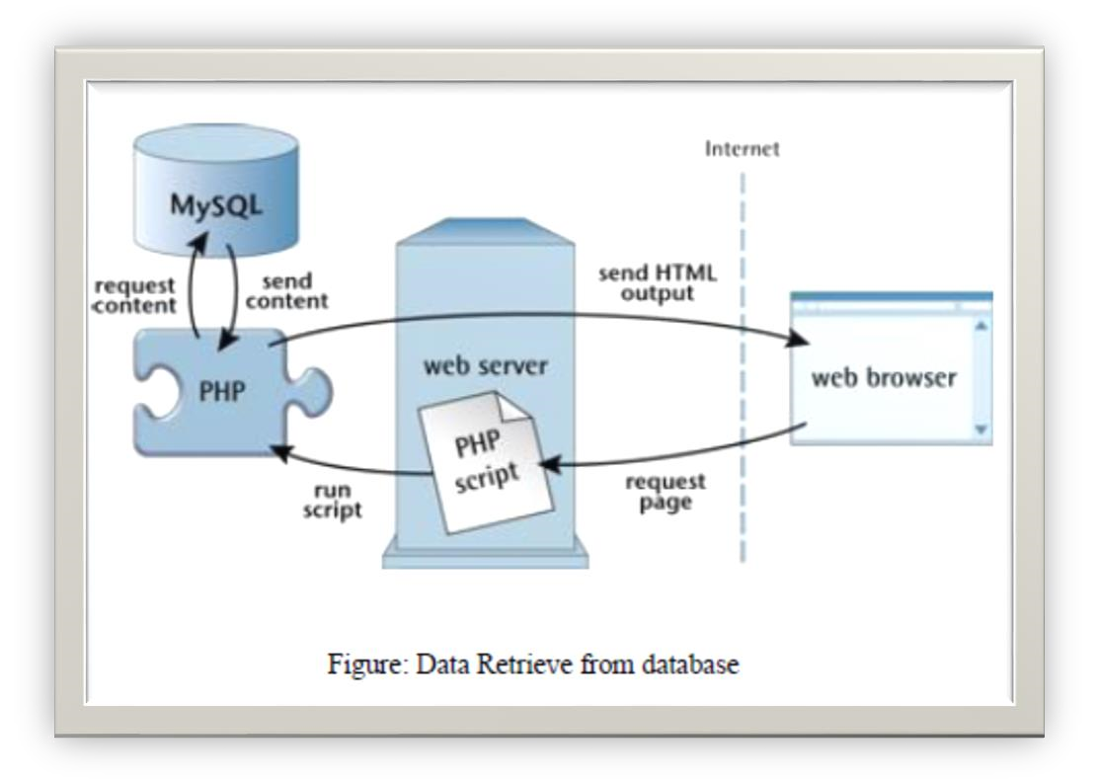 

**USER INTERFACE**



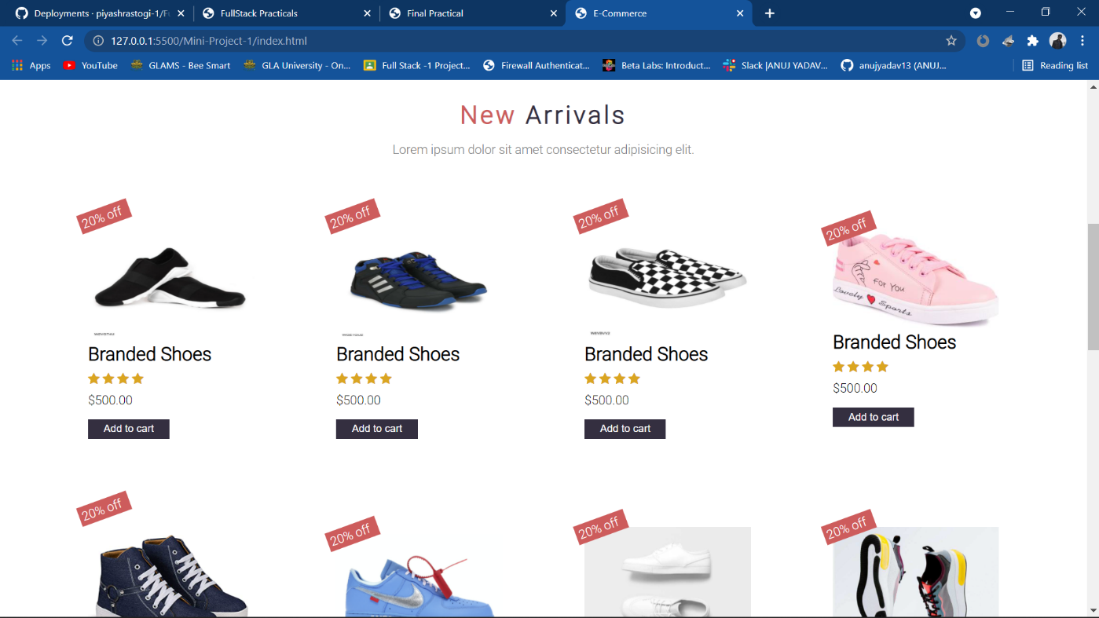

# Software Testing

# 

## Why Software Testing is Needed

Tool-bars work properly? Are all menu function and pull-down sub function properly listed? Is it possible to invoke each menu function using a logical assumption that if all parts of the system are correct, the goal will be successfully achieved? In adequate testing or non-testing will leads to errors that may appear few months later. Testing represents an interesting anomaly for the software engineer. During earlier software engineering activities, the engineer attempts to build software from an abstract concept to a tangible product. Now comes testing. The engineer creates a series of test cases that are intended to “demolish” the software that has been built. In fact, testing is the one step in the software process that could be viewed (psychologically, at least) as destructive rather than constructive. Testing requires that the developer discard preconceived notions of the “correctness” of software just developed and overcome a conflict of interest that occurs when errors are uncovered.

## Testing Strategy

There are types of testing that we implement. They are as follows:

This creates two problems:

1. Time delay between the cause and appearance of the problem.
2. The effect of the system errors on files and records within the system.

The purpose of the system testing is to consider all the likely variations to which it will be suggested and push the systems to limits. The testing process focuses on the logical intervals of the software ensuring that all statements have been tested and on functional interval is conducting tests to uncover errors and ensure that defined input will produce actual results that agree with the required results. Program level testing, modules level testing integrated and carried out.

There are two major types of testing they are:

1. White Box Testing.
2. Black Box Testing.

## White Box Testing

White box sometimes called “Glass box testing” is a test case design uses the control structure of the procedural design to drive test case. Using white box testing methods, the following tests were made on the system

1. All independent paths within a module have been exercised once. In our system, ensuring that case was selected and executed checked all case structures. The bugs that were prevailing in some part of the code where fixed
2. All logical decisions were checked for the truth and falsity of the values.

**Black Box Testing**

Black box testing focuses on the functional requirements of the software. This is black box testing enables the software engineering to derive a set of input conditions that will fully exercise all functional requirements for a program. Black box testing is not an alternative to white box testing rather it is complementary approach that is likely to uncover a different class of errors that white box methods like.

* Interface errors.
* Performance in data structure.
* Performance errors.
* Initializing and termination errors.

**Conclusion & Future Enhancement**

**Conclusion**

This project is only a humble venture to satisfy the needs in a shop. Several user-friendly coding has also adopted. This package shall prove to be a powerful package in satisfying all the requirements of the organization. The objective of software planning is to provide a frame work that enables the manger to make reasonable estimates made within a limited time frame at the beginning of the software project and should be updated regularly as the project progresses.

**Future Aspect**

The project has a very vast scope in future. The project can be implemented on intranet in future. Project can be updated in near future as and when requirement for the same arises, as it is very flexible in terms of expansion. With the proposed software of database Space Manager ready and fully functional the client is now able to manage and hence run the entire work in a much better, accurate and error free manner.

The following are the future scope for the project.

* Should be added payment gateway
* Can be added inventory management system
* Can be added multiple branches
* Can be added multilingual to this site
* And many features can be added this project to make it more robust.

### GITHUB PROJECT LINK:

<https://github.com/anujyadav13/Mini-Project-1>